# Scenario of a Basic Flight – Traverse Terminal Airspace

1. Passengers embark onto the aircraft.
2. The aircraft pushes back from the terminal.
3. The aircraft taxis to the runway.
4. The aircraft takes off.
5. The aircraft may climb into EnRoute airspace and then may climb, cruise, or descend as needed.
6. The aircraft may descend from EnRoute airspace.
7. Upon arrival, the aircraft may hold as needed.
8. The aircraft taxis to the exit of the runway.
9. The aircraft taxis to the gate.
10. The passengers disembark the aircraft.

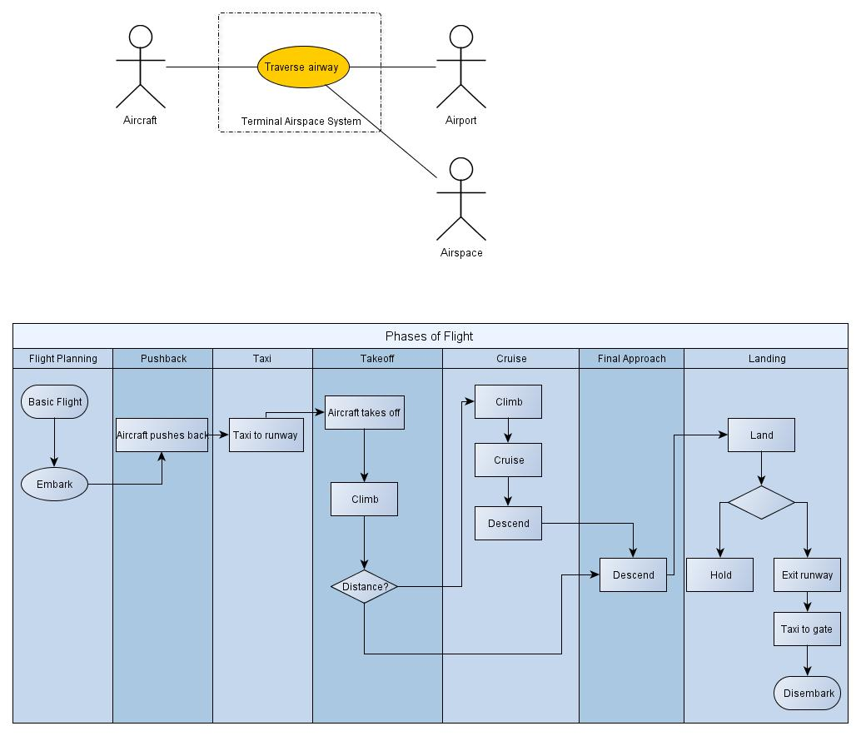

The Monterey Phoenix Language

